**Year 3 – Spring Term -** Makey Makey

**Key Vocabulary:**

Pulley

Lever

Conductor

Control

Mechanical systems

Design

Create

Evaluate

Computer

‘Makey Makey’

Inventions

Technology

Future

Load

Force

Fulcrum

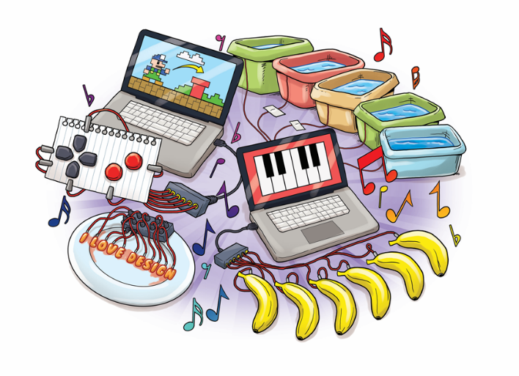

**At the end of the topic the children will know that:**

* The Makey Makey is a piece of equipment that allows them to control computers.
* They can connect everyday objects to make computer keyboards.
* Only materials, which are conductors, will work but these can be only slightly conductive to work.
* Some materials that will work include bananas, play doh, marshmallows and water.

**Summary:**

This term the children will be making a Banana Keyboard using Makey Makey. They will make control and monitor models using software designed for this purpose. Before creating they will design a game controller and learn how to control a computer using everyday objects. Using different materials they will investigate which make good conductors.

As well as this, they will design and create pinball machines, explain pulleys and levers.

Texts we will be reading:

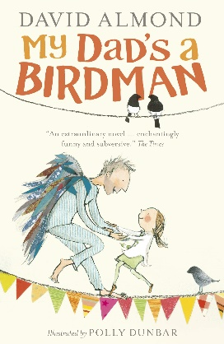

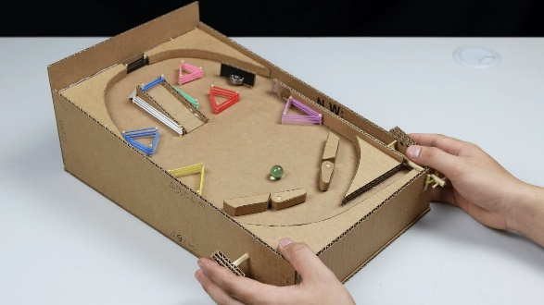

**In Design and Technology we will be learning to:**

* To understand how key events and individuals in design and technology have helped shape the world.
* To understand and use mechanical systems in their products [for example, gears, pulleys, cams, levers and linkages]
* Use scientific knowledge of the transference of forces to choose appropriate mechanisms for a product (such as levers, winding mechanisms, pulleys and gears).
* Design and make a pinball machine.
* Apply our knowledge of forces to make the pinball machine work.
* Design with purpose by identifying opportunities to design.
* Make products by working efficiently (such as by carefully selecting materials).
* Use research and develop design criteria to inform the design of innovative, products that are aimed at particular individuals or groups
* To generate their ideas through discussion, annotated sketches.
* Refine work and techniques as work progresses, continually evaluating the product design.
* To control and monitor models using software designed for this purpose
* Design a game controller.
* To learn how to control a computer using everyday objects.
* To investigate which materials will work.



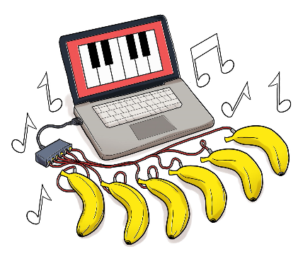

**At the end of the DT topic I will know:**

What is needed to create effective design, thinking carefully about how it will appeal to a range of audiences. I will know how to design with purpose, refine my work and techniques as work progresses and continually evaluating the product design. I will then think carefully about what worked well for me and what I would change if I made the product again.

I will know that pulleys and levers are used in mechanical devices and that a lever is a simple machine which helps us to project objects.

I will know that the object you are lifting is called the load, and the force you apply to the arm to make the object move is called the effort.

A pulley is a simple machine that makes it easier to lift or move a heavy object. It includes at least one wheel and a length of rope.

Makey Makey:

I will know how to use a piece of equipment called the Makey Makey, which will enable me to control computers using everyday objects such as bananas. I will know that conductors allow electricity to travel through them and I can use this along with the Makey Makey. I will know how to make a banana keyboard by connecting wires to the bananas and then to the Makey Makey. The Makey Makey is a piece of equipment that allows me to control computers.

I will be able to connect everyday objects to make computer keyboards.

I will explore only with materials, which are conductors, which will work but

these can be only slightly conductive to work. An electrical conductor is a material

that allows electricity to flow through it. Wires need to connect with a conductor to

make the product work. Electricity can flow through a banana and water. We will look at different materials

that will work include bananas, play doh, marshmallows and water.

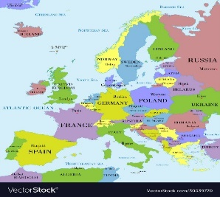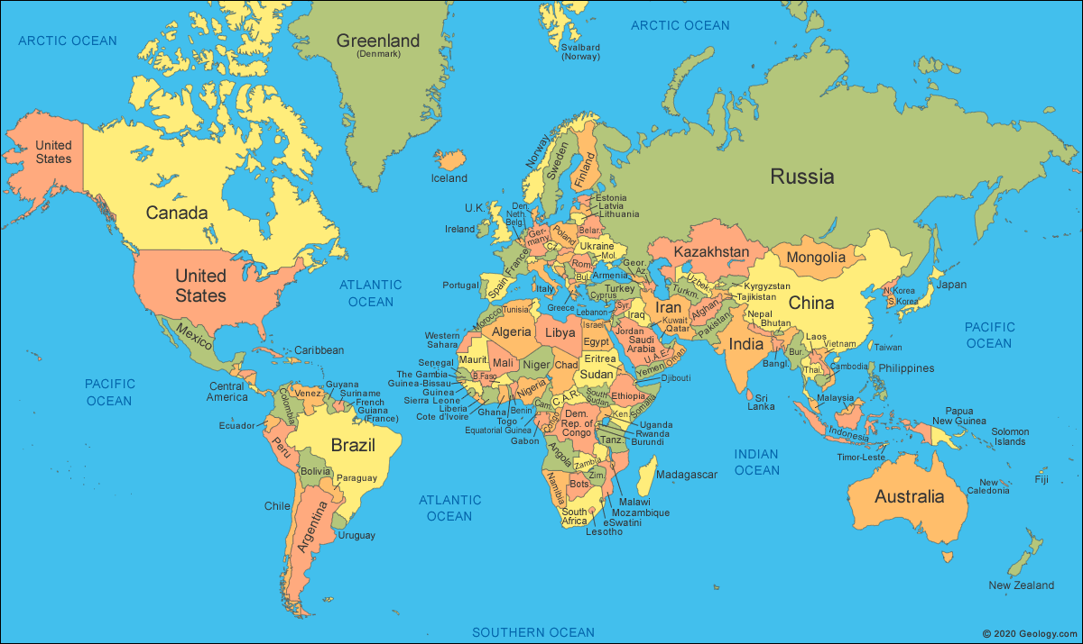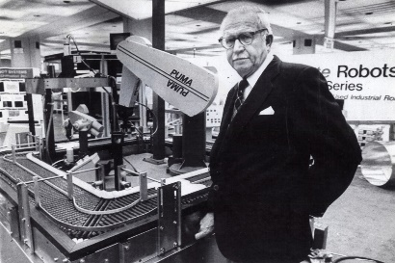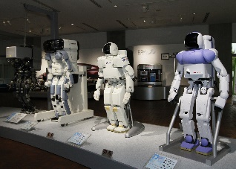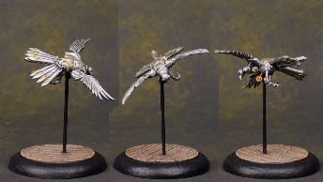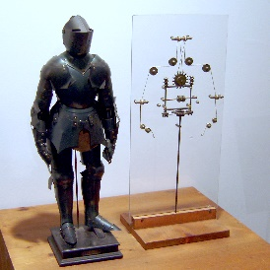

**In Geography I will learn:**

* To locate countries in Europe and the world using maps.

**At the end of this topic I will know:**

How to use an atlas to find the location of different countries in Europe and the world. I will be able to locate different countries on a map of Europe and the World.

**In History I will learn:**

* Describe accounts of a historical event.
* Place events on a time line using dates.
* Use evidence to find answers to questions about the past.

**By the end of this term I will know:**

Robot is a **Czech** word ’robota’ that means forced work or labour. A robot is a man-made machine that can perform work or other actions normally performed by humans, either automatically or by remote control. The first ever robot was created in the 5th century BC by Archytas of Tarentum in the form of mechanical doves. Leonardo da Vinci drew plans for a robotic machine, kind of an armoured humanoid in 1495. The first humanoid robot was Elektro built by Westinghouse in 1939.

Overtime, robots have changed so that they no longer look like people. The most successful of this kind was designed in the 20th century. George Devol made the first of these, the Unimate, in 1954, with one arm and one hand.

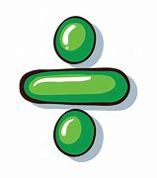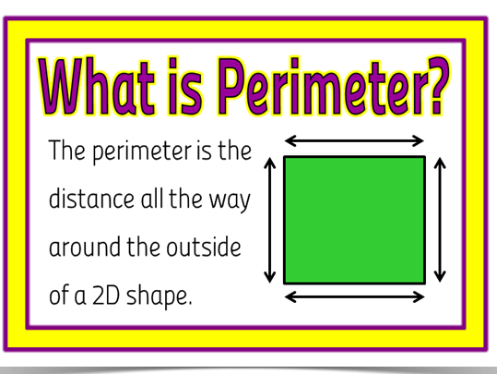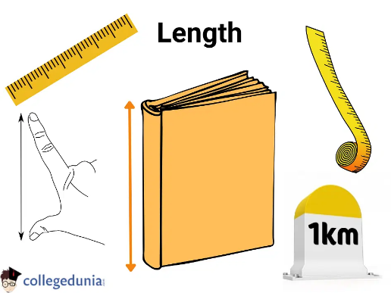

**In Maths we will be learning to:**

**Multiply and divide 2-digit numbers by 1-digit**

* To use multiples of 10
* To use related calculations
* To multiply a 2 digit by 1 digit number (no exchange)
* To multiply a 2 digit by 1 digit number (exchange)
* To divide a 2-digit number by 1 digit (no remainders)
* To  divide a 2 digit number by 1 digit (no exchange)
* To  divide a 2 digit number by 1 digit (flexible partitioning)
* To  divide a 2 digit number by 1 digit (with remainders)

**Length and Perimeter**

* To measure in m and cm
* To  measure in mm
* To measure in cm and mm
* To find equivalent lengths (m and cm)
* To find equivalent lengths (mm and cm)
* To compare lengths
* To add lengths
* To subtract lengths
* To understand perimeter
* To measure perimeter
* To calculate perimeter

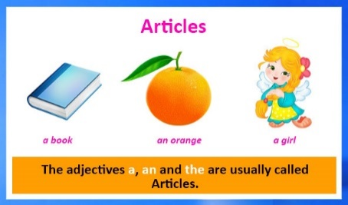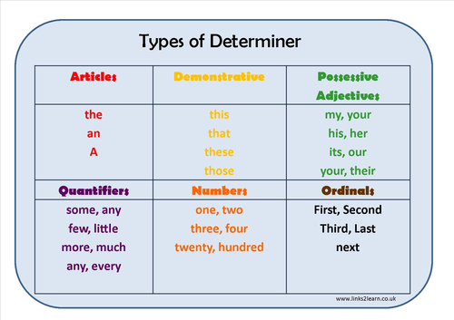

**In English we will be learning to:**

Write in a variety of styles including a narrative (a warning story), a persuasive leaflet and a poem based on the text that we will read ‘My Dad’s a Birdman’ . During these lessons children will get the opportunity to identify the features of the text type, use the features in their writing along with editing and redrafting their work. Children will also use their speaking and listening skills when carrying out role play activities.

In our Grammar lessons the children will be learning about adverbs, conjunctions, inverted commas, when to start a new paragraph and articles and determiners.

Articles are words used before nouns and they modify nouns. There are three articles: a, an, the.

Determiners, in English grammar, are a type of word that comes before a noun to introduce it and provide

additional information about the quantity and proximity of the noun. It helps give the reader or listener

more context. For example, 'this plate' or 'my house

Books we will read:

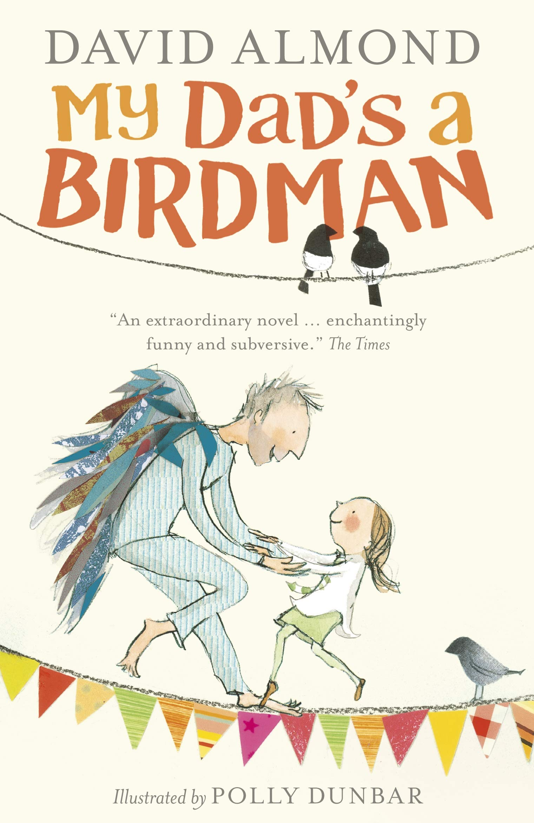

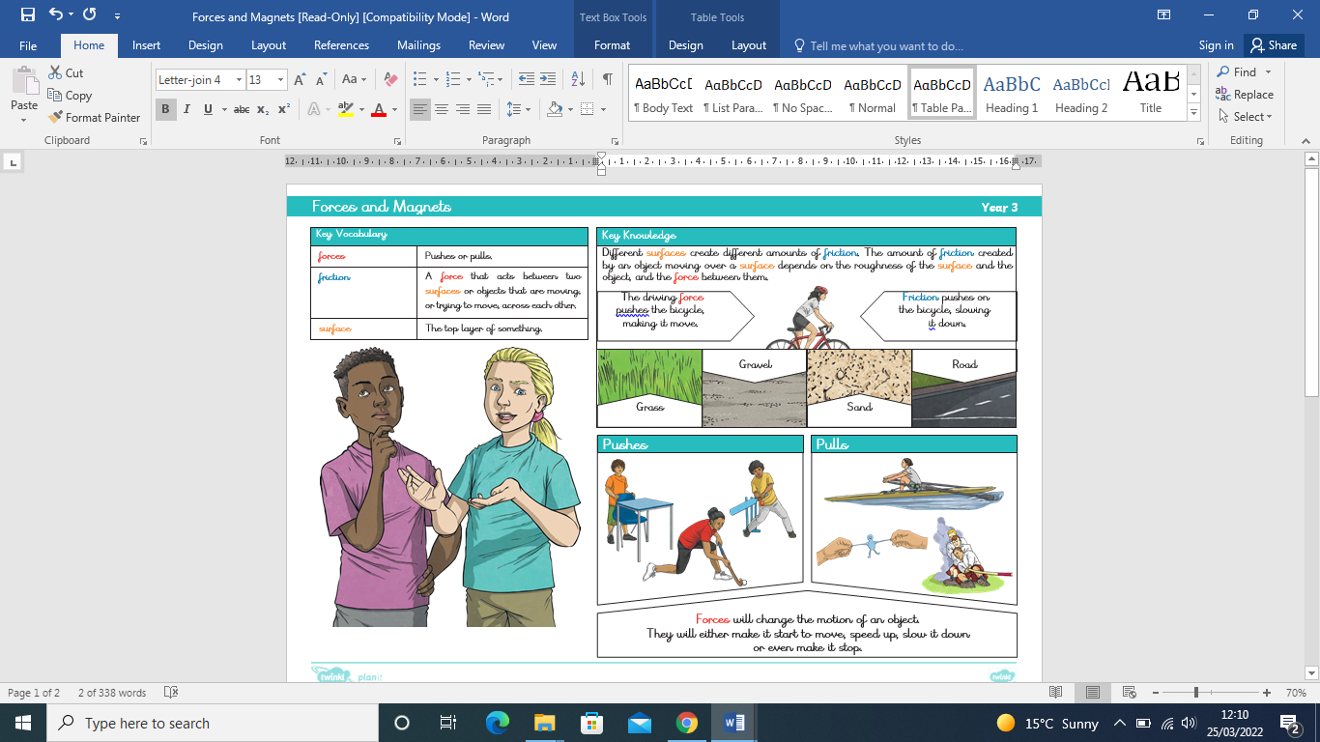

**In Science we are learning to:**

* To identify the forces acting on objects.
* To investigate how a toy car moves over different surfaces.
* To sort magnetic and non-magnetic materials
* To investigate the strength of magnets
* To explore magnetic poles
* To observe how magnets attract some materials

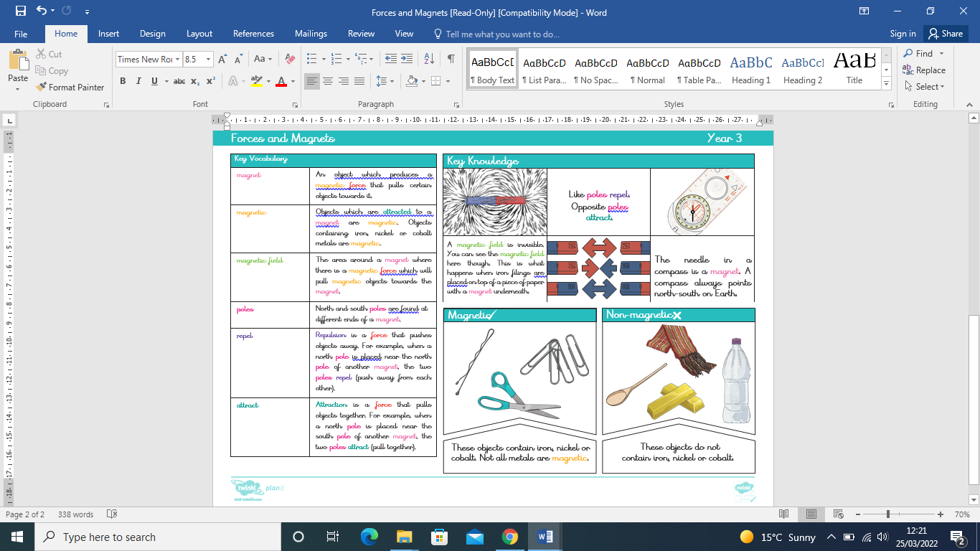

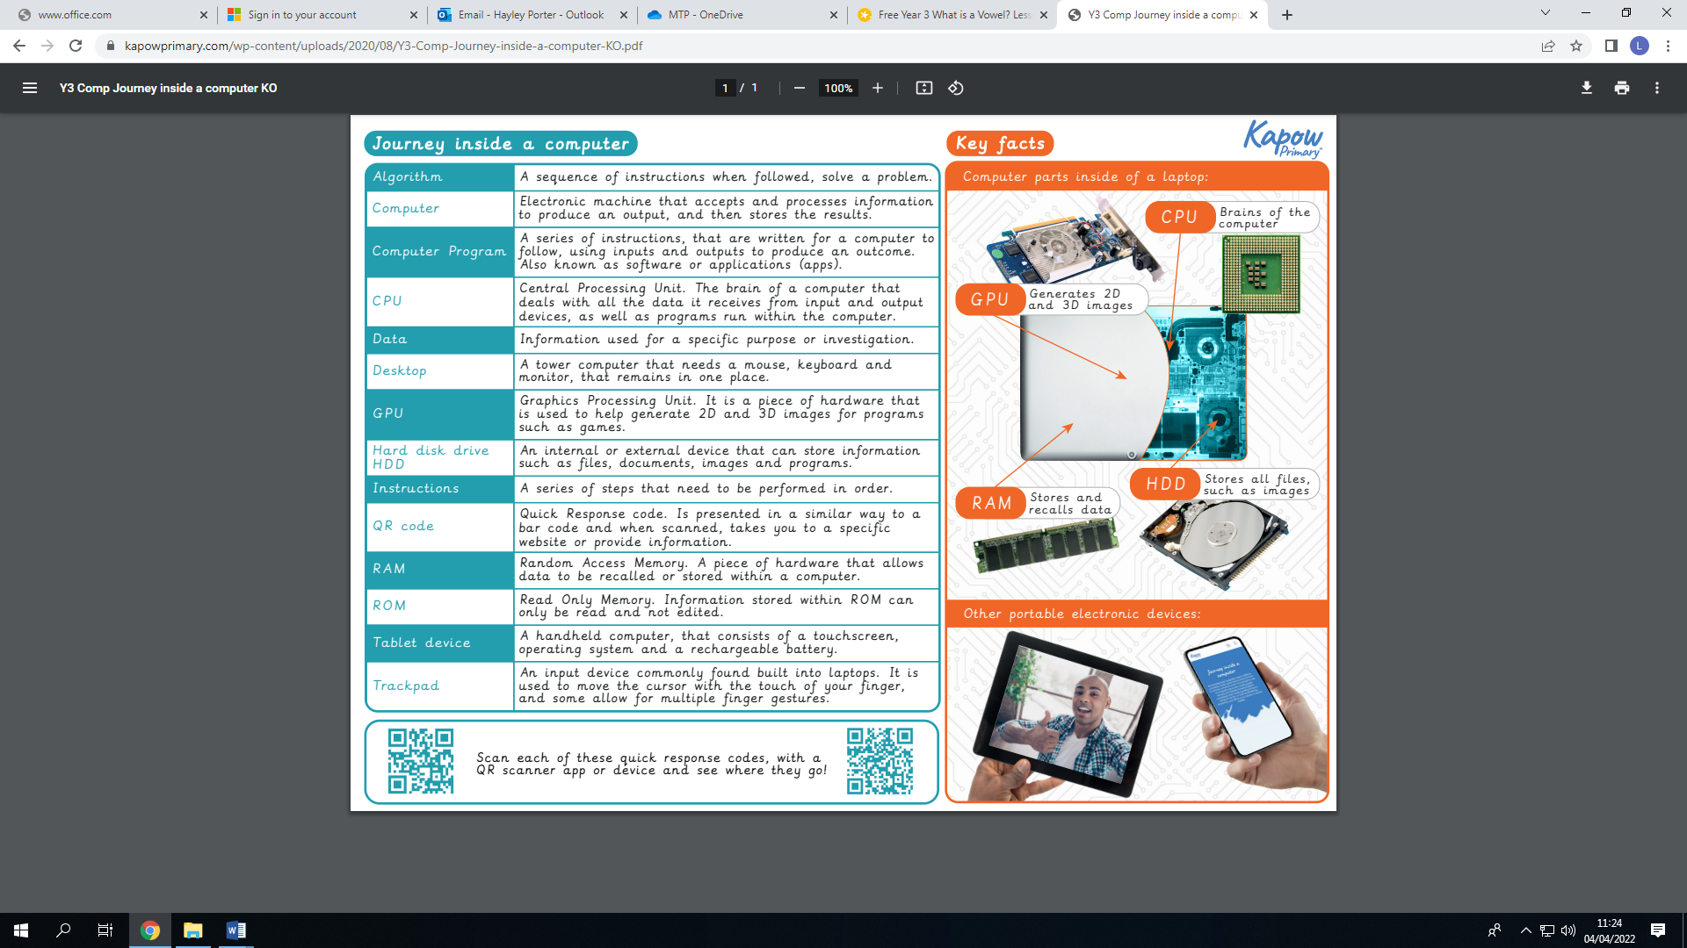

**Computing**

**At the end of the unit I will know:**

* To recognise basic inputs and outputs
* To decompose a laptop
* To understand the purpose of computer parts
* To decompose a tablet computer

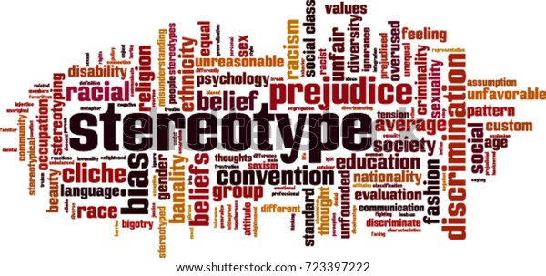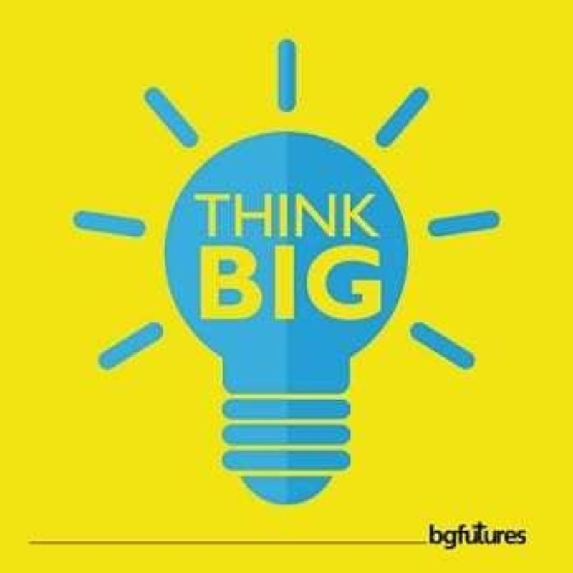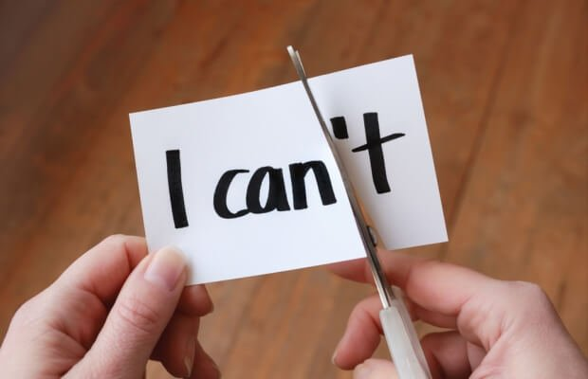

**PSHE**

**In PHSE we will be learning**:

* To know what is meant by ‘stereotypes’.
* To know what is means to be ‘enterprising’
* To know about working collaboratively towards shared goals
* To recognise their achievement and set personal targets for the future.

In PSHE, I will be learning about what jobs we would like.

What a stereotype is and why we should not make an assumption about what someone will do or how they will behave based on what social groups they belong to. An enterprise is when you are willing to do things that require energy and imagination and sometimes result in money as a reward for your efforts. I will know what qualities are needed for ‘enterprising’ and reflect on the class enterprise. Working collaboratively involves a group of two or more people working together towards a common goal. Teams may work together to develop a product, complete a project or solve a problem. I will know how to reflect on my achievement throughout the year, identifying my strengths and areas for improvements. I will know the importance of setting high aspirations and goals for the year ahead.

**PE**

**In PE I will be learning:**

Gymfit circuits

LO: To identify techniques to improve balance.

LO: To practise a range of gymnastic skills through a series of circuits.

LO: To perform a range of gymnastic skills with increased accuracy.

LO: To perform a sequence of gymnastic moves within a circuit.

LO: To perform a sequence of moves at each station within a circuit with increased accuracy

LO: To perform a sequence of moves at each station within a circuit with increased accuracy

